# Data Science Capstone

**Introduction**

**Background & Discussion**

With increasing awareness of the climate change movement on the rise. The push to reduce CO2 emissions is louder than before. On the business end, the opportunities to gain capital rise as well. Many industries will argue that a sudden requirement to adapt will have great bearings on the economy. Bloomberg reports that the global economy must invest $1.8 trillion by 2030 to prepare for the effects of global warming. Bloomberg also reports that fighting climate change will aide economic growth. A large part of this argument being the skyrocketing costs spent on natural disasters in the last 30 years.

On September 20, 2019 the German government announced an agreement to set a price on carbon emissions in a bid to meet a 2030 climate target of cutting greenhouse gases by 55% on 1990 levels. The plan will boost initiatives on “going green”. VAT (sales tax) on rail tickets is set to fall from 19% to 7% on 1 January 2020 and operator Deutsche Bahn said it would waive any price increase. A further €1bn of annual investment is planned until 2030 to modernize and expand the rail network to cope with an expected increase in passengers.

**Problem**

This report centers around the last point. As current Chicago resident, I believe it’s only a matter of time until this coalition becomes Global and we are all required participate by law.

The problem will be the sudden increase in gas prices due to carbon taxes, ceilings on industry CO2 emissions and the transferring burden to consumers.

**Interest**

The goal of this report is to provide current and incoming businesses with most common venue data focused around the Chicago Transit Authority (CTA) train service.

The value added for business will be data analytics to aide with new venues around The City of Chicago. Considering the increasing foot traffic near transit stops.

**Data**

**Data Source & Description**

The Data was sourced from Github. The dataset includes coordinates (latitude and longitude) to entrances/exists of all CTA train line (Red, Blue, Brown, Green, Orange, Pink, Purple, Yellow) stops.

Data downloaded will be cleaned and simplified so that each point includes the stops latitude/longitude coordinates and the respective train line. I will use the Foursquare API to explore the most common venues near all train lines. This data will help us group the transit stops into clusters and analyze each.

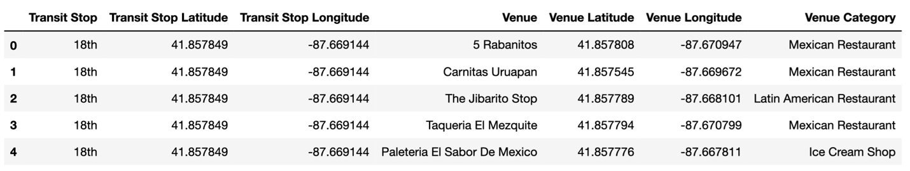

**Methodology & Analysis**

**Algorithm**

We will use the k-means clustering algorithm. K-means clustering is a simple but popular unsupervised machine learning algorithm. Why? K-means clustering works exceptional well with numerical data. Output behavioral segmentation data by grouping and creating profiles based on common venues.

Our input vectors will be the CTA transit stop coordinates and the Foursquare most common venues dataset. This will compare and find certain similarities between each cluster. It will give business insights into Chicago transit stop areas.

**Exploratory Data Analysis**

The geopy library was used to get the latitude and longitude values of Chicago. Folium was used for data visualization. The dataframe has 109 transit stops.

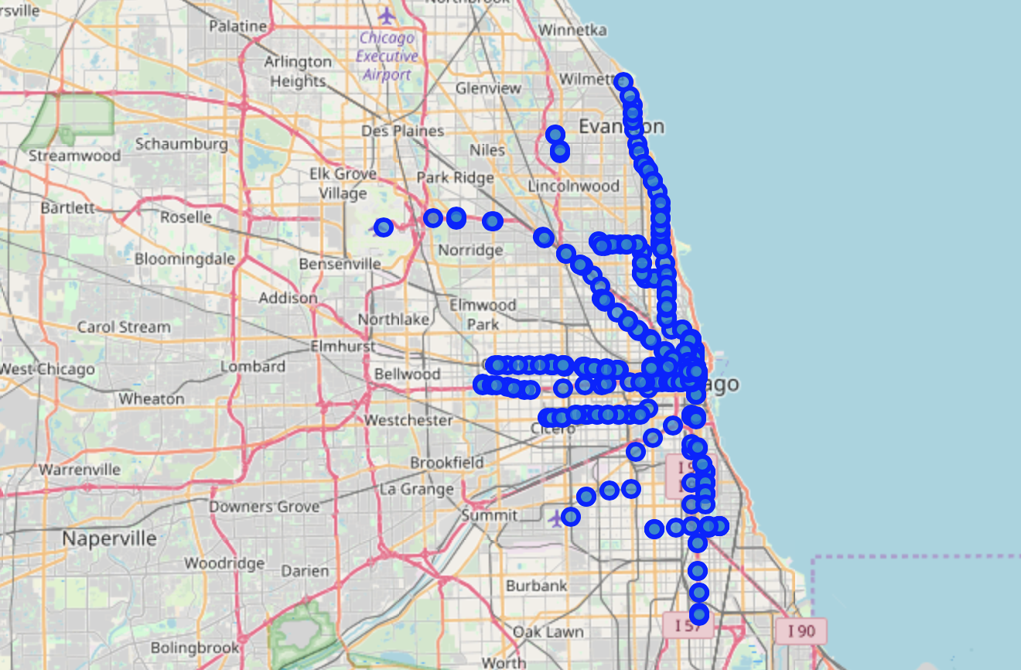

I looked at the nearby venues in a 500meter radius. Analyzed each Transit Stop and Top 5 most common venues. Explored the amount of venues for each transit stop. Then ran k-means to cluster transit stops into 5 clusters. Created dataframe to store clusters and top 5 venues for each transit stop.

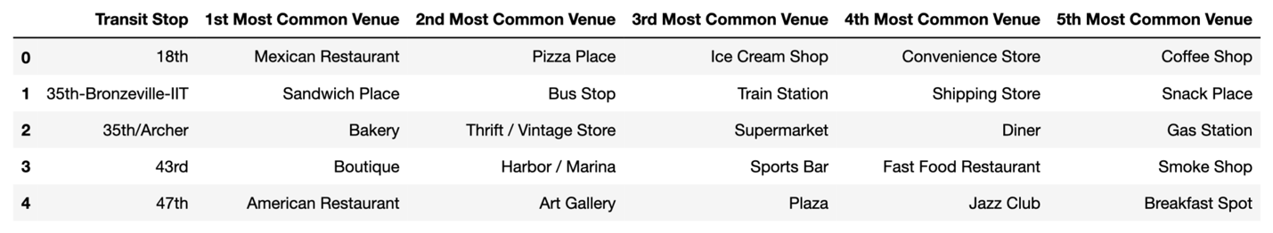

**Results**

**Observations & Discussion**

365 unique categories. 35 venues returned by Foursquare. Restaurants and Hotels are the most common venues for transit stops closest to downtown. General entertainment, parks and grocery stores are much more common as you get further away from downtown.

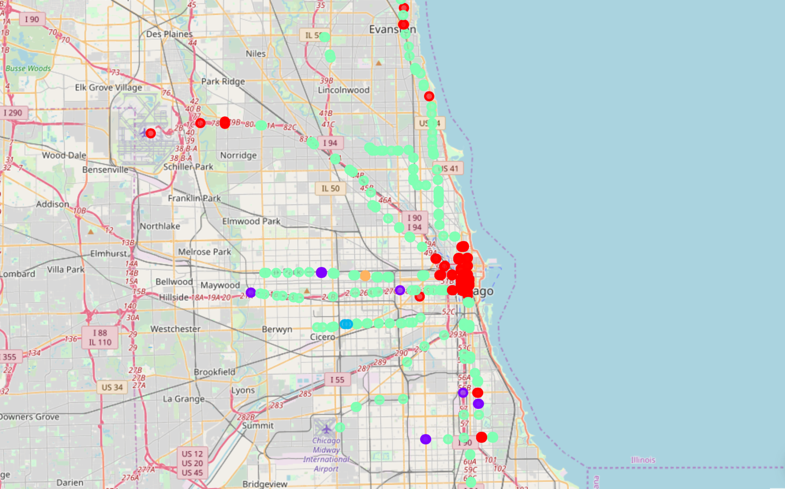

**Recommendations**

Prospective business owners can use this data to differentiate. Strategically place services such as bikes, scooters or other transit sharing business.

**Conclusion**

Multiple use cases for prospective business. Creating profiles based on activity monitoring. Defining personas based on interests

# Works Cited

https://www.bloomberg.com/news/articles/2019-08-19/fighting-climate-change-will-help-economic-growth-study-finds

https://www.bloomberg.com/news/articles/2019-09-09/the-massive-cost-of-not-adapting-to-climate-change